EXCALIBUR SHIELD  Shielding Against MIC  Description:  Excalibur shield is made of 316L stainless steel which can precisely acquire liquid and solid samples to monitor and mitigate internal pipeline corrosion. It is incorporated with a primary filtering system at the  mouth of a 100 ml cavity, a weight loss coupon inside the cavity with a secondary filtering system that surrounds the coupon.  Product Features:  - Corrosion resistant 316L SS  - Corrosion coupon holder option  - MOP: 2000psi  - Sessile bacteria monitoring  - Planktonic Bacteria Monitoring  - Chemical Residue Monitoring  - Solid Sample Monitoring  Additional components:  Disc coupon mounting device can be installed between the mouth of the Excalibur Shield body and the safety isolation valve to measure the MPY in the solids.  3-Rod coupon mounting device installed in the cavity of the Excalibur Shield provides measurement of the MPY, full coverage testing, oxygen testing, and etc. | 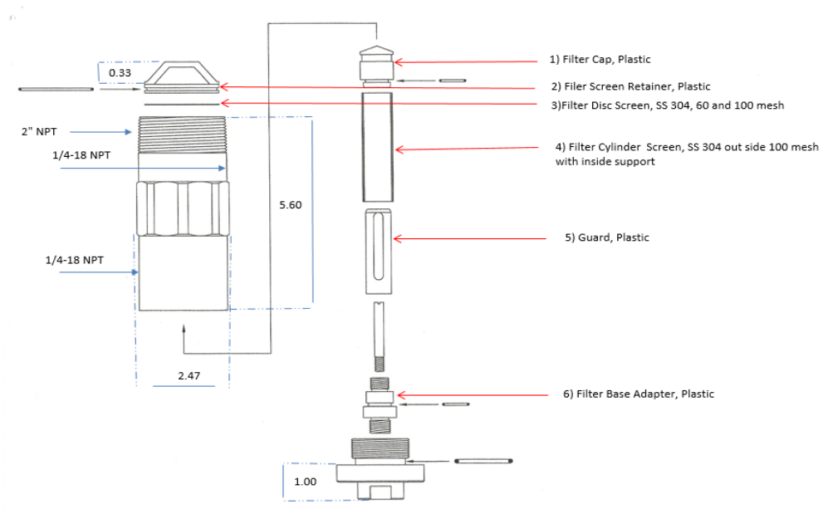  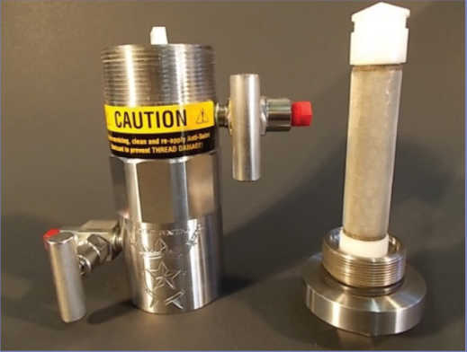  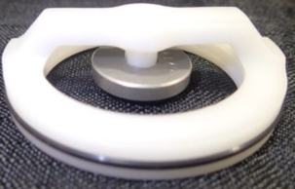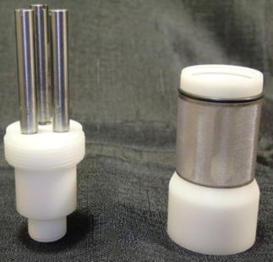  5-minute video bar code:

P.O. Box 741 Midland, TX 79702
jgallo@cathodic-protection-solutions.com
https://www.cathodic-protection-solutions.com/
Phone: 432.230.6955 ISN: 400-220357
P.O. Box 741 Midland, TX 79702
jgallo@cathodic-protection-solutions.com
https://www.cathodic-protection-solutions.com/
Phone: 432.230.6955 ISN: 400-220357
P.O. Box 741 Midland, TX 79702
jgallo@cathodic-protection-solutions.com
https://www.cathodic-protection-solutions.com/
Phone: 432.230.6955 ISN: 400-220357
P.O. Box 741, Midland, TX 79702
jgallo@cathodic-protection-solutions.com
https://www.cathodic-protection-solutions.com/
Phone: (432)230-6955, ISN: 400-220357

